**HTML <i> Tag**

Last Updated : 26 Aug, 2024

The **<i> tag** in HTML is used to display the content in italic style. This tag is generally used to display the technical term, phrase, the important word in a different language. The *<i> tag* is a container tag that contains the opening tag, content & closing tag.

**Syntax**

// Inline way to make italic text in html file  
<i> Now content is Italic </i>  
  
// Use in external style.css file to make italic  
i {    
 font-style: italic;  
}

**Usage**

* Use the *<i> tag* for words that you want to show differently from the normal phrase for readability purposes.
* These semantic elements give contextual significance to text, while <i> primarily focuses on the text’s appearance.
* Use *<i> tag* only when it is not marked up with these elements:   
  + [<em>](https://www.geeksforgeeks.org/html-em-tag/)
  + [<strong>](https://www.geeksforgeeks.org/html-strong-tag/)
  + [<mark>](https://www.geeksforgeeks.org/html5-mark-tag/)
  + [<cite>](https://www.geeksforgeeks.org/html-cite-tag/)
  + [<dfn>](https://www.geeksforgeeks.org/html-dfn-tag/)

**Accepted Attributes**

The <i> tag is also supported by [Global attribute](https://www.geeksforgeeks.org/html-global-attributes/) and [Event Attributes](https://www.geeksforgeeks.org/html-event-attributes-complete-reference/) in HTML.

**Example 1:**This is a simple example illustrating the *<i> tag* to make the italic text in HTML.



1

<!DOCTYPE html>

2

<html>

3

​

4

<head>

5

<title>HTML i Tag</title>

6

</head>

7

​

8

<body>

9

<h1>GeeksforGeeks</h1>

10

<h3>HTML i tag</h3>

11

<div>

12

<p>

13

<i>A Computer Science portal for geeks.</i>

14

It contains well written, well thought and well

15

explained computer science and programming articles

16

</p>

17

</div>

18

</body>

19

​

20

</html>

**Output:**

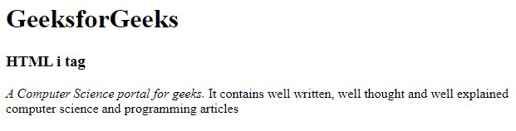

*HTML Tag*

**Example 2:** In this example, we have used *<i> tag* & *<p> tag* to illustrate the difference in the text appearance while rendering it.



1

<!DOCTYPE html>

2

<html>

3

​

4

<head>

5

<title>HTML Italic Tag</title>

6

</head>

7

​

8

<body>

9

<h1>GeeksforGeeks</h1>

10

<h3>HTML i tag</h3>

11

<p>This is normal text written inside p tag</p>

12

​

13

<!--HTML <i>(italic) tag is used here-->

14

​

15

<i>This text is in italic font style</i>

16

</body>

17

​

18

</html>

**Output:**

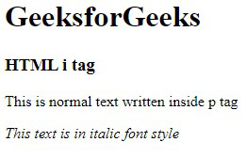

*Italic font-style using HTML Tag*

**Example 3:** A text can be written in italics using CSS also. When the [CSS font-style property](https://www.geeksforgeeks.org/css-font-style-property/) is set to italic, then the text can be seen as follows:



1

<!DOCTYPE html>

2

<html>

3

​

4

<head>

5

<title>HTML Italic Tag</title>

6

</head>

7

​

8

<body>

9

<h1>GeeksforGeeks</h1>

10

<h3>HTML i tag</h3>

11

​

12

<!--Example for font-style: italic -->

13

<p style="font-style: italic;">

14

This text content is in italic font.

15

</p>

16

​

17

<h5>Note:This example is only possible when the

18

font-style property is kept "italic" in CSS

19

</h5>

20

</body>

21

​

22

</html>

**Output:**

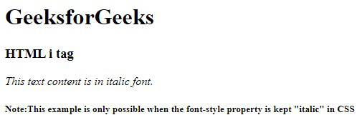

*Setting font-style to italic using font-style Property*

**Supported Browsers**

* Google Chrome 1 and above
* Microsoft Edge 12 and above
* Firefox 1 and above
* Opera
* Safari